Cab Service System

# Microservice Design

Diagram

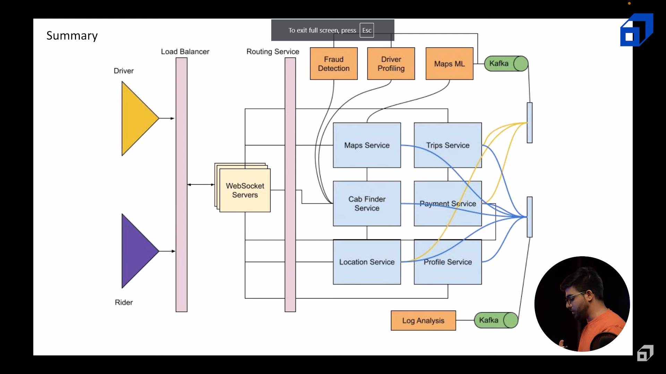

# Services

List of Services

1. User-service
2. Map-service
3. Trip-service
4. Cab-finder-service
5. Location-service
6. Payment-service
7. Map-service
   1. Navigate()
      1. localhost:8081/api/v1/map/navigate?sourceLat=49.932707&sourceLon=11.588051&destLat=50.3404&destLon=11.64705&vehicle=car&debug=true&key=cceb673a-91d5-4e84-a9b2-adff379ce38d&type=json&points_encoded=false
8. Payment-service
   1. getEstimatedPrice()
      1. localhost:8082/api/v1/map/navigate?sourceLat=49.932707&sourceLon=11.588051&destLat=50.3404&destLon=11.64705&vehicle=car&debug=true&key=cceb673a-91d5-4e84-a9b2-adff379ce38d&type=json&points_encoded=false

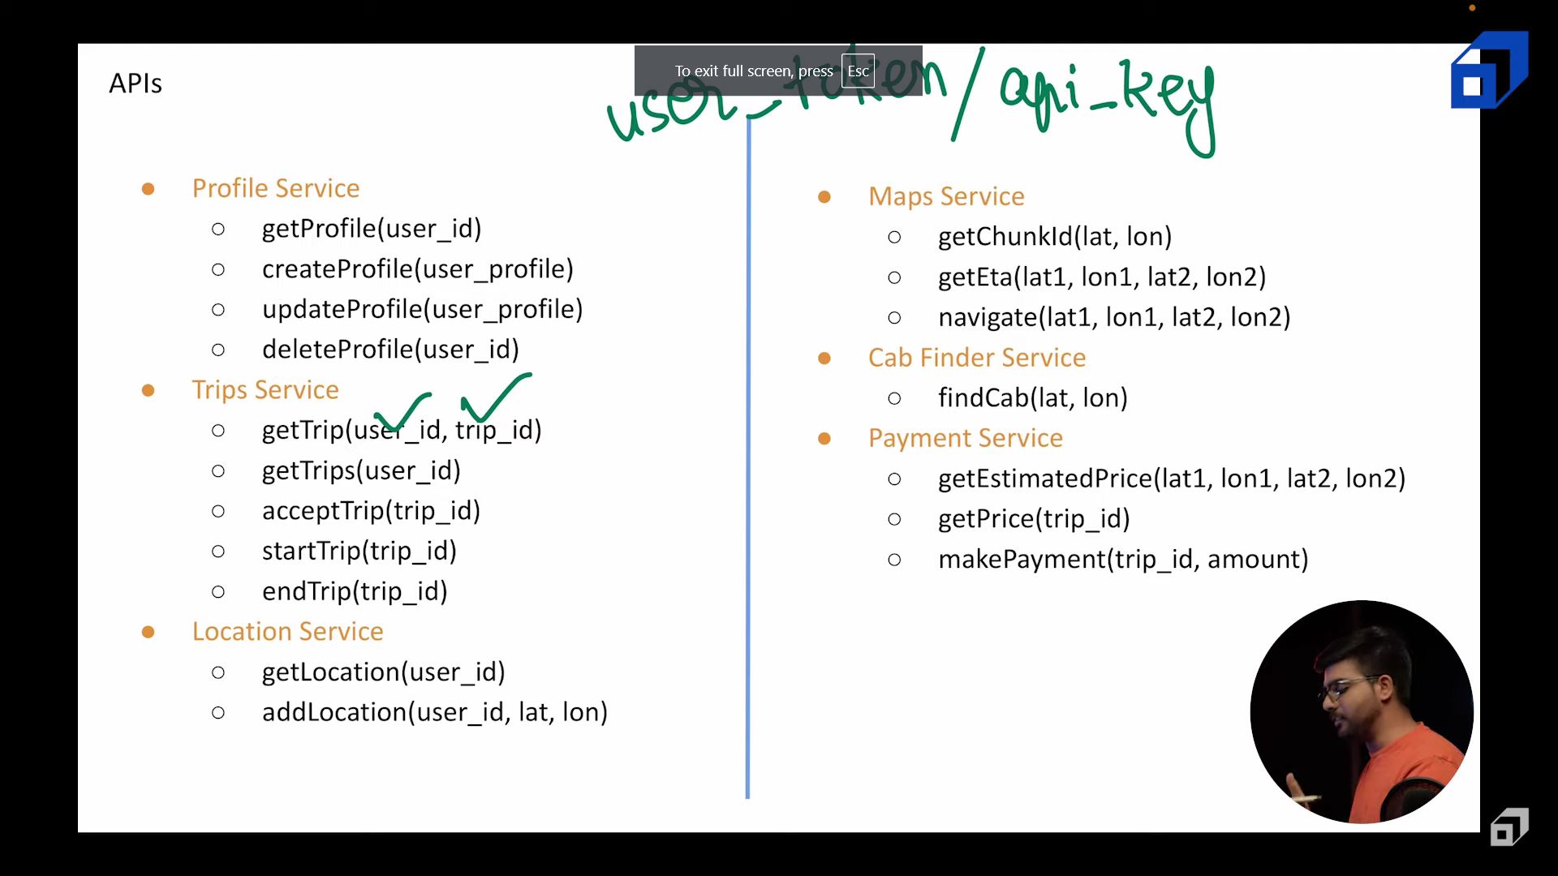

# Databases against the services

Databases list

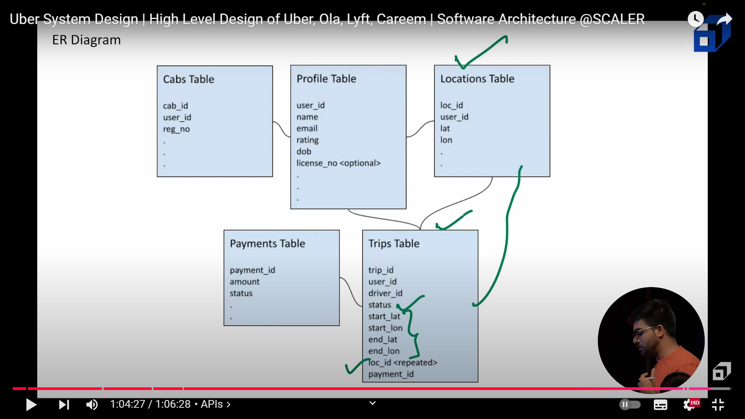

1. User-table
   1. User_id
   2. Name
   3. Email
   4. role
   5. Rating
   6. Date of birth
   7. License number
   8. Cab_id
2. Trip-table
   1. tripId
   2. userId
   3. driver_id
   4. status
   5. start_lat
   6. start_lon
   7. end_lat
   8. end_lon
   9. list of location followed
   10. paymentId
3. Cab-Finder service – cab table
   1. Cab_id
   2. User_id
   3. Reg_no
4. Location-service- geospatial Coordinate
   1. Latitude
   2. Longitude
   3. Geohash
   4. cabId
5. Payment-service
   1. paymentId
   2. amount
   3. status

|  |  |  |  |
| --- | --- | --- | --- |
| Sr No. | Service Name | Server Port |  |
| 1 | Map-service | 8081 |  |
| 2 | Payment-service | 8082 |  |
| 3 | Profile-service | 8083 |  |
| 4 | Api-gateway | 8080 |  |
| 5 | Service-registry | 8761 |  |
| 6 | Trip-service | 8084 |  |